**League of American Orchestras Webinar**

**"Taking Another Listen: Engaging New Audience Members of Color"**

**September 2024**

**WSSO D&I Committee responses**

**From Mary Ellen Baxter:**

*Yes, I viewed the webinar. It was quite interesting. I think you are very conscious of the need to engage artists and composers of color for our concerts. I think we can be more intentional  about advertising. It was mentioned in the webinar to survey the community to see what can connect the audience of color to classical music. Many think it's boring to listen to classical music but can be caught singing catchy commercials or humming cartoons.  
We might have to send Embassators to community  events with our posters. I did click on save the pdf. If I have other thoughts, I'll send them to you.  
Mary Ellen Baxter.*

**From Charles Yocum:**

*I don't have a lot of feedback regarding the recording.  I believe you have done an excellent job of including music and artists reflecting a diverse group of people over the past several years:*

*Florence Price in 2020*

*Jerod Impichchaachaaha Tate and Danielle Carr in 2021*

*Scott Joplin, Capital Area Music Association and Erin Graham in 2022*

*Joseph Bologna, Coleridge-Taylor Perkinson, Samuel Coleridge-Taylor, Eric Hinton and Jose Elizondo in 2023*

*I'm not sure how much it's impacted the diversity of our audience, but it certainly has exposed those who attend our concerts to a wide variety of diverse artists.  Thank you for your efforts.*

**Some transcriptions & Power Point highlights of the webinar**

**excerpted by Jennifer Sacher Wiley**

**Who Listens to Classical Music**

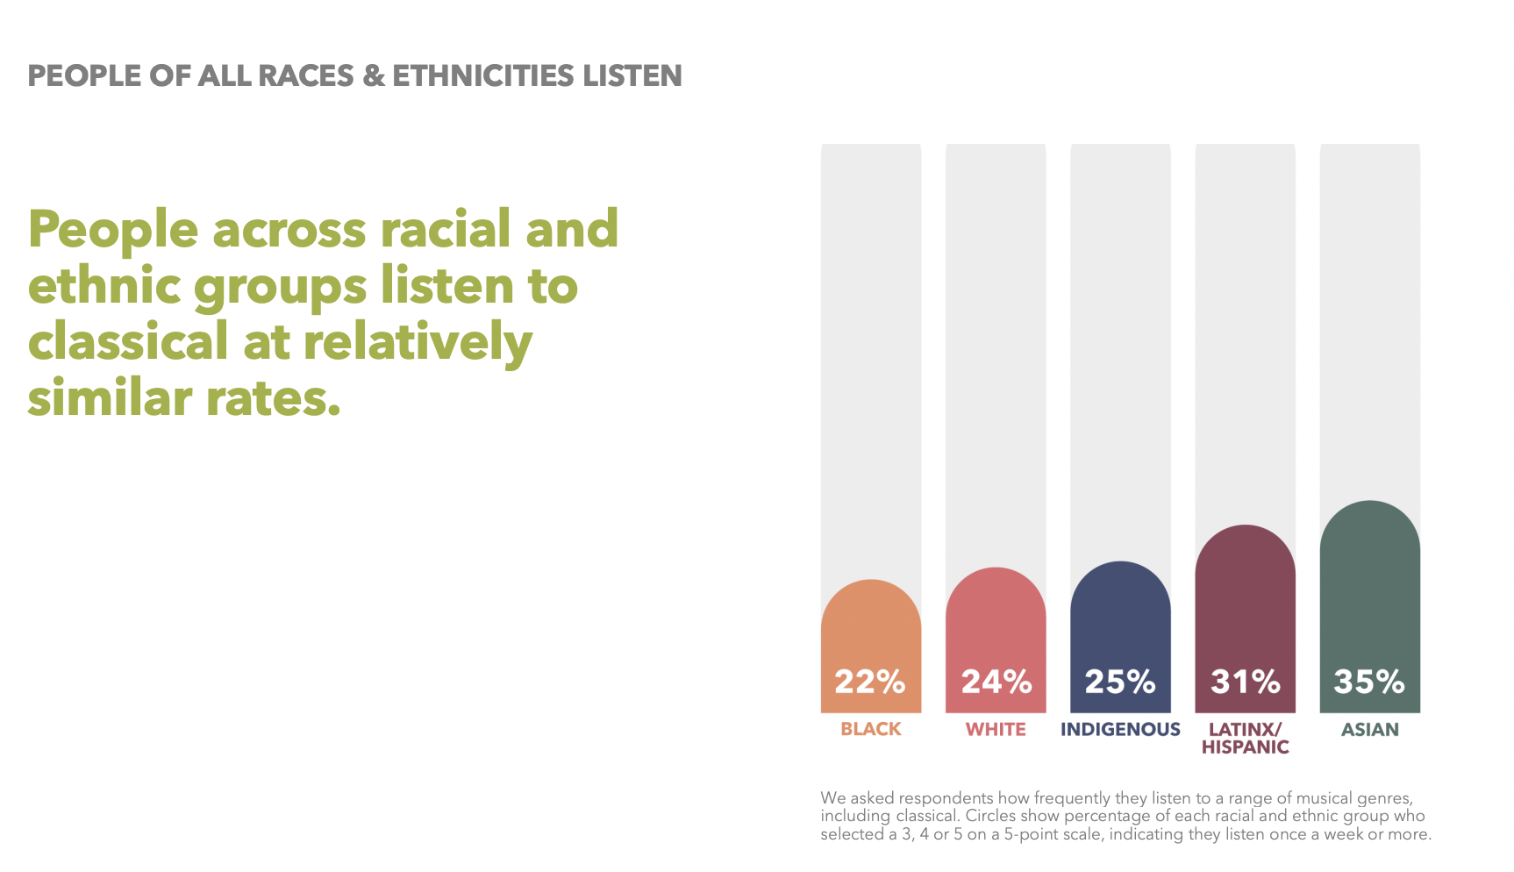

**Why People Don’t Listen to Classical Music**

**The Social Environment of an Orchestra Concert**

**Young People**

**Encouraging a First-Time Experience with Classica Music**

**Partnerships with Local Artists, Bridging other Genres**

**Marketing what Music Director Programs**

